**Scholarly Quarter**

**Critical Insights into Research: A Quarterly Review**

**Introduction:**

In the ever-evolving landscape of educational management, the need for efficient student data management and meaningful engagement has become paramount. Recognizing this imperative, we present the "Student Quarter Project," a comprehensive initiative designed to enhance student experiences and streamline administrative processes.

This project delves into the intricate details of student information, introducing a robust system that encompasses student tables, a feedback form, and an image repository. By centralizing student data, providing a platform for constructive feedback, and visually capturing the essence of our student community, this endeavor seeks to revolutionize the way we understand, interact with, and support our students.



**Purpose and Objectives:**

**Student Data Management:**

Establish a centralized and accessible repository for student information, encompassing academic records, personal details, and relevant data points.

**Feedback Form Implementation:**

Integrate a user-friendly feedback mechanism to encourage students to share their experiences, challenges, and suggestions, fostering open communication.

**Image Repository:**

Create an image gallery that visually represents the diversity and achievements of our student body, providing a dynamic snapshot of campus life.

.

**Why I Chosen This?:**

Recognizing the importance of student engagement beyond academic metrics, you may have chosen the project to create mechanisms for students to actively contribute their experiences, challenges, and suggestions, fostering open communication and collaboration.

**Website Development:**

**Project Selection*:***

This Scholarly Quartet project selected based on the problem statement and I prefer to work with real world I had chosen this student theme for my project.In this project details about my friends and me are there.

The project might involve leveraging technology to modernize and optimize existing systems. The integration of digital tools can enhance administrative efficiency and provide a more dynamic platform for student interaction.

**Project Objectives:**

* Improve the efficiency of student data management.
* Enhance communication and engagement between students, faculty, and administrators.
* Create a visually appealing representation of the student community through an image repository.

**Project Features/Functionalities:**

* Student Data Management:
  + Personal details, academic records, and relevant information.
* Feedback Form:
  + User-friendly interface for students to provide feedback.
  + Data storage and retrieval of feedback.
* Image Repository:
  + Image upload functionality.
  + Display and categorization of images.

**Technology Stack:**

1. **MongoDB:**
   * **Role:** MongoDB is a NoSQL database that stores data in a flexible, JSON-like format.
   * **Usage:** It is used to store and retrieve data related to student information, feedback, and other relevant details in a structured manner.
2. **Express.js:**
   * **Role:** Express is a web application framework for Node.js, simplifying the process of building robust and scalable web applications.
   * **Usage:** It is employed to handle routing, middleware, and API endpoints on the server side. Express interacts with MongoDB to fetch and update data.
3. **React.js:**
   * **Role:** React is a JavaScript library for building user interfaces, providing a declarative and efficient way to design interactive UIs.
   * **Usage:** React is utilized for creating the front-end of your application. It allows you to build modular, reusable components that dynamically update based on user interactions. The pie charts and user interface components are likely implemented using React.
4. **Node.js:**
   * **Role:** Node.js is a JavaScript runtime that allows you to execute JavaScript code on the server side.
   * **Usage:** Node.js is the backend runtime for your application. It handles server-side logic, communicates with the database (MongoDB), and serves data to the front end.
5. **HTML:**
   * **Role:** HTML (Hypertext Markup Language) is the standard markup language for creating web pages.
   * **Usage:** HTML is used to structure the content of your web pages. It defines the elements and their hierarchy, including forms, buttons, and other interactive elements.
6. **CSS:**
   * **Role:** CSS (Cascading Style Sheets) is used for styling web pages, defining the presentation and layout.
   * **Usage:** CSS styles are applied to HTML elements to control the visual presentation of your application. It ensures a consistent and visually appealing user interface.
7. **Material-UI (MUI):**
   * **Role:** Material-UI is a popular React UI framework that provides pre-built React components following Google's Material Design principles.
   * **Usage:** MUI components are used to create a consistent and aesthetically pleasing user interface. This includes buttons, forms, and other UI elements.

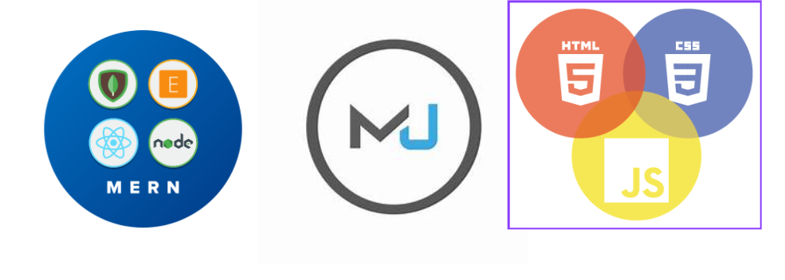

**User Interface (UI) Design:**

### 1. User-Centric Design:

* Understanded users and their needs. Designed with the end-users in mind.
* Conducted user research and gather feedback to inform my design decisions.

**2. Intuitive Navigation:**

* Create a clear and intuitive navigation structure.
* Users can easily find and access essential features and information.

**3. Consistent Design Language:**

* Maintaining consistency in design elements, including colors, fonts, and button styles.

**4. Responsive Design:**

* responsiveness to a seamless experience across various devices and screen sizes.

**Main page of the website:**

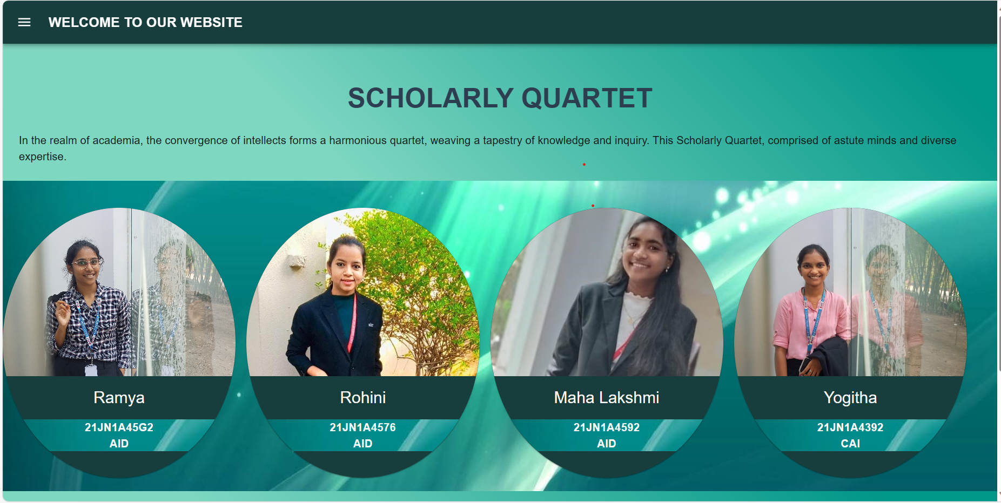

Here is my main page which contain the cards nav bar and side bar which have the data of four girls and it has the main menu which can navigate to the next pages .

**Side bar and Nav bar:**

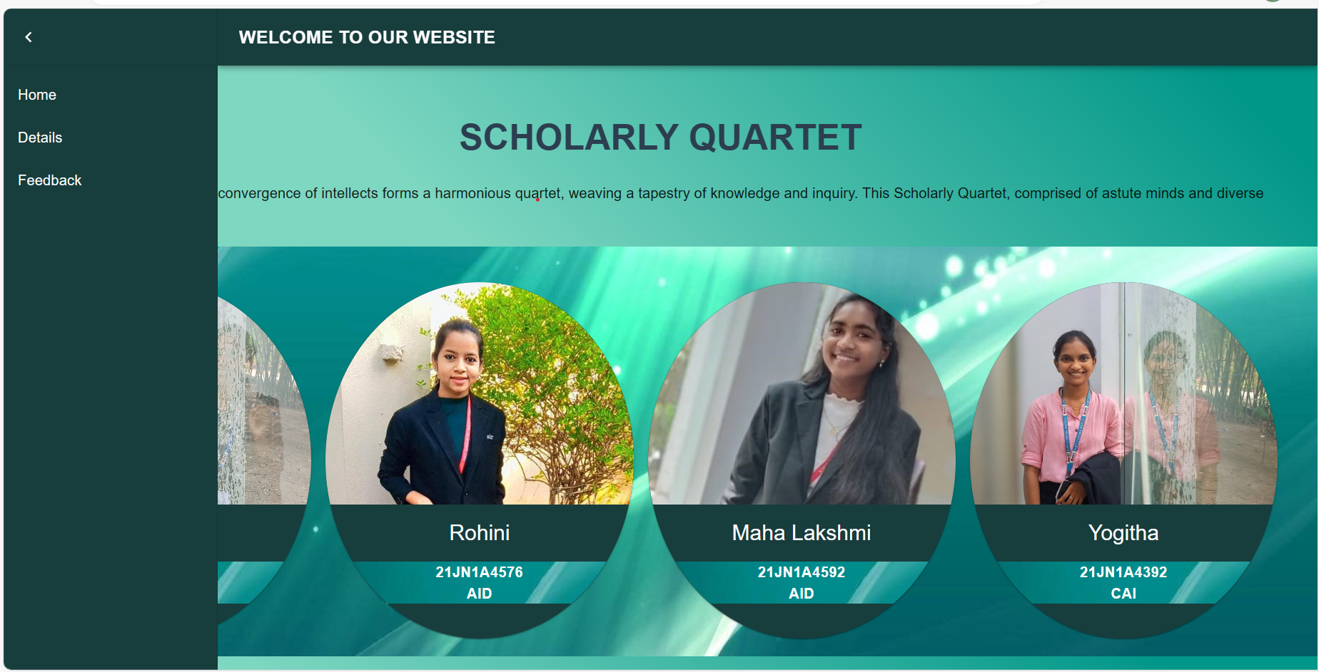

**Details Naviagtor:** 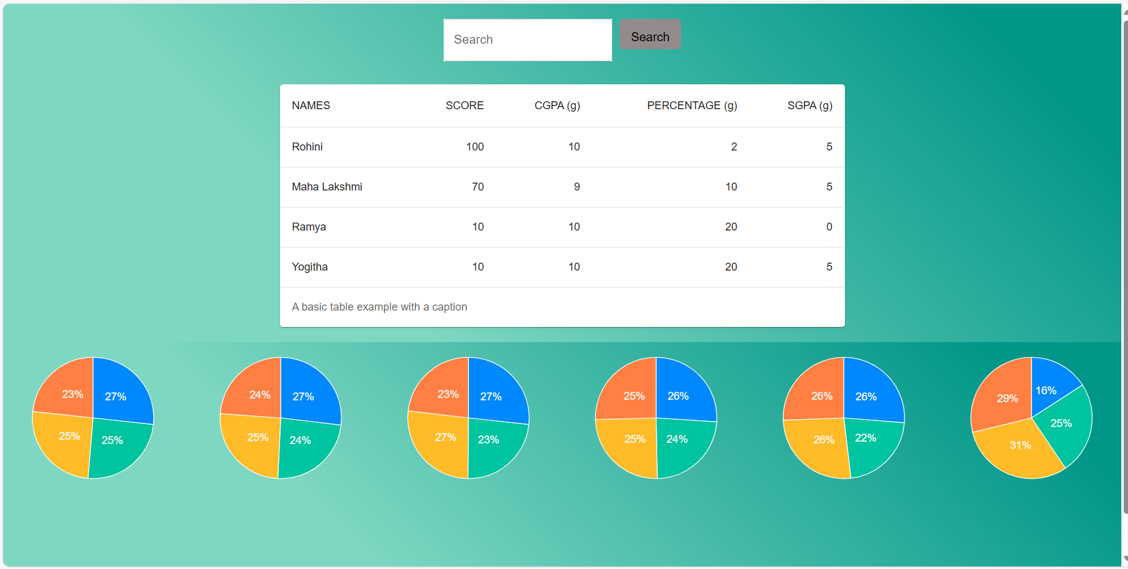

This page contain the cgpa score and marks of the students and it contain the piecharts of the data and it might be useful for students but I had done it for only four of my friends.

**Feedback Form Design:**

* Form structure and fields.
* Validation and submission process.

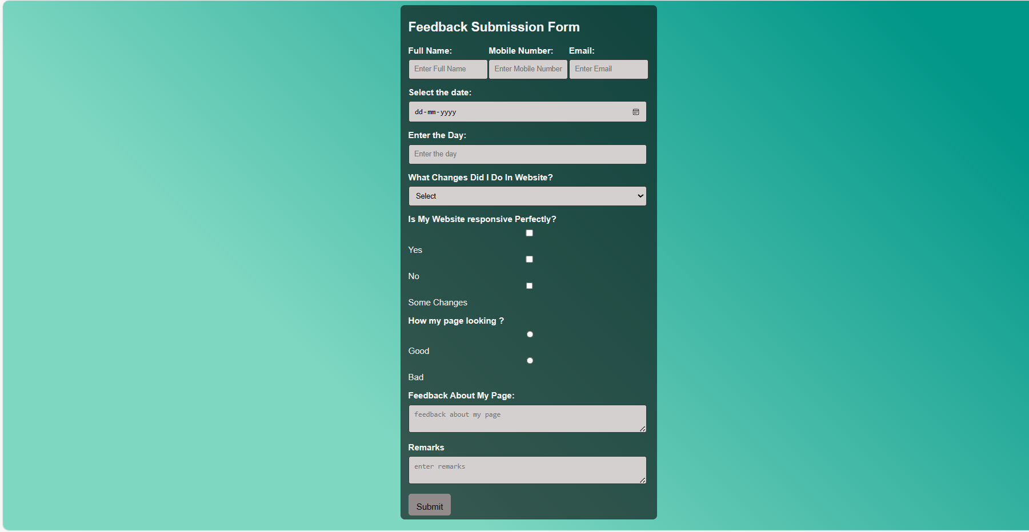

**Folder structure:**

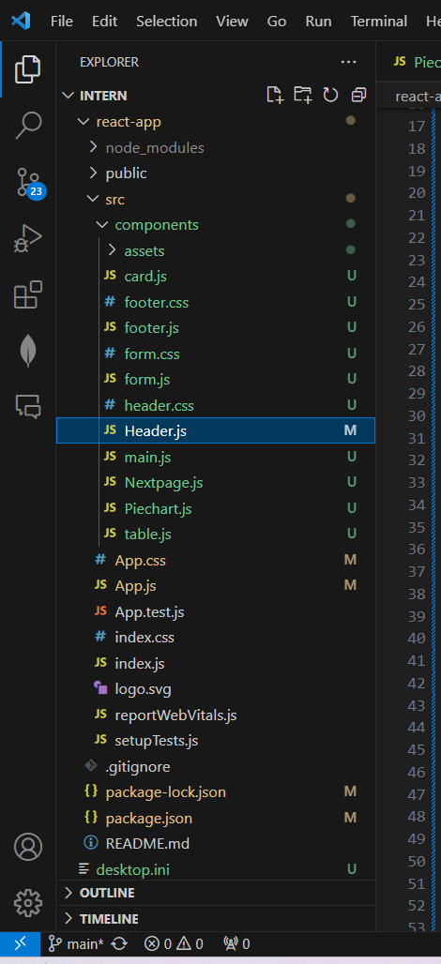

**Code snippest**: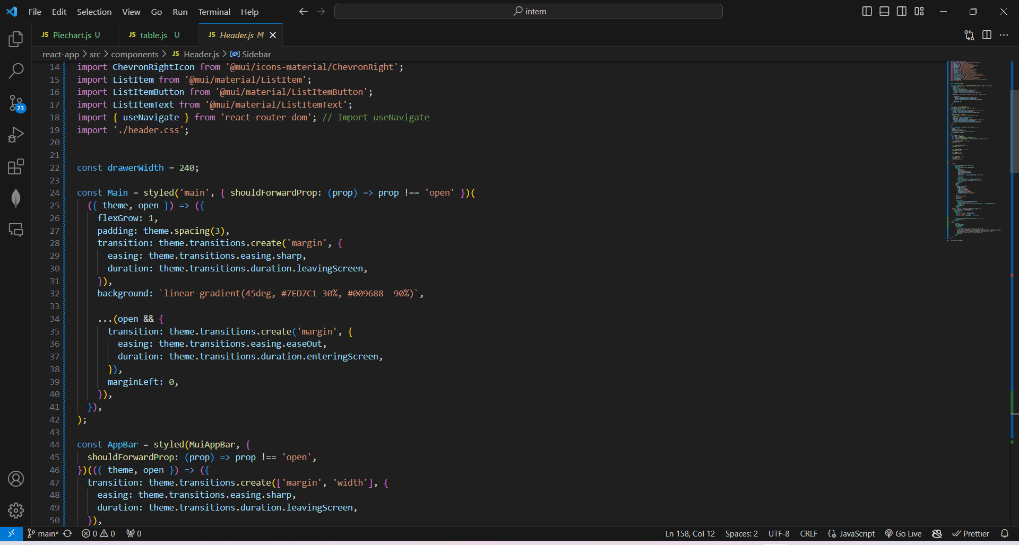

**Model Deployment:**

**GitHub Repository*:***

**Welcome to the Student Quarter Project Repository!**

MY GitHub repository serves as the central hub for all resources related to the Student Quarter Project, providing a transparent and collaborative space for my project and the wider community. Here, you'll find the source code, documentation, and resources that power the Student Quarter Project.

project. Please follow this ( [https://github.com/yogisay1263](https://github.com/yogisay1263o)) to access the GitHub repository and explore our Student Quarter project.

**LinkedIn Profiles*:***

Please follow this [(https://www.linkedin.com/in/yadla-yogitha-124122229/](https://www.linkedin.com/in/yadla-yogitha-124122229/)) to access my Linkedin for my profile.

**Future Work*:***

Certainly! It sounds like you have some exciting plans for the future development of your Student Quarter Project. Here's a brief outline of the future work you intend to undertake:

**Main page implementation:**

* **Objective:**
  + Improve the overall accessibility of the application to cater to users with diverse needs.
* **Tasks:**
  + Implement accessibility features, such as screen reader compatibility and keyboard navigation.
  + Conduct usability testing to identify areas for improvement in user-friendliness.

**Feedback Implementation**

* **Objective:**
  + Establish a structured method for storing and analyzing feedback data.
* **Tasks:**
  + Design and implement a backend system to store feedback securely.
  + Implement analytics tools to derive insights from the collected feedback.

**Conclusion:**

As the Student Quarter Project progresses along this roadmap, it aspires to be a versatile, user-friendly, and scalable solution that meets the evolving needs of students, faculty, and administrators. The commitment to continuous improvement and responsiveness to user feedback ensures that the project remains a valuable asset within the educational ecosystem.

In essence, the Student Quarter Project is not just a platform; it is an evolving initiative dedicated to fostering a positive and collaborative educational environment. Through innovation, adaptability, and a user-centric approach, the project aspires to leave a lasting impact on the student community.

Anomaly